SALES ANALYSIS USING SQL

1.Load dataset into a SQL database.

Firstly I have loaded the dataset and made changes in the table.

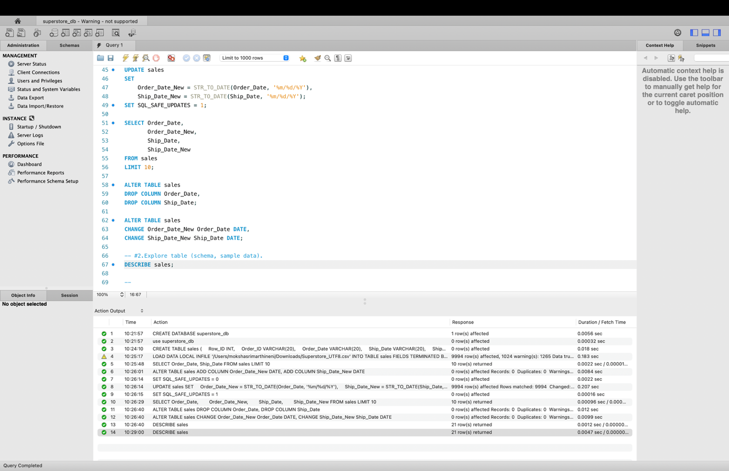

Here I have analysed the schema of the table, made changes accordingly and the output is given above in the screenshot.

2.Explore table (schema, sample data).

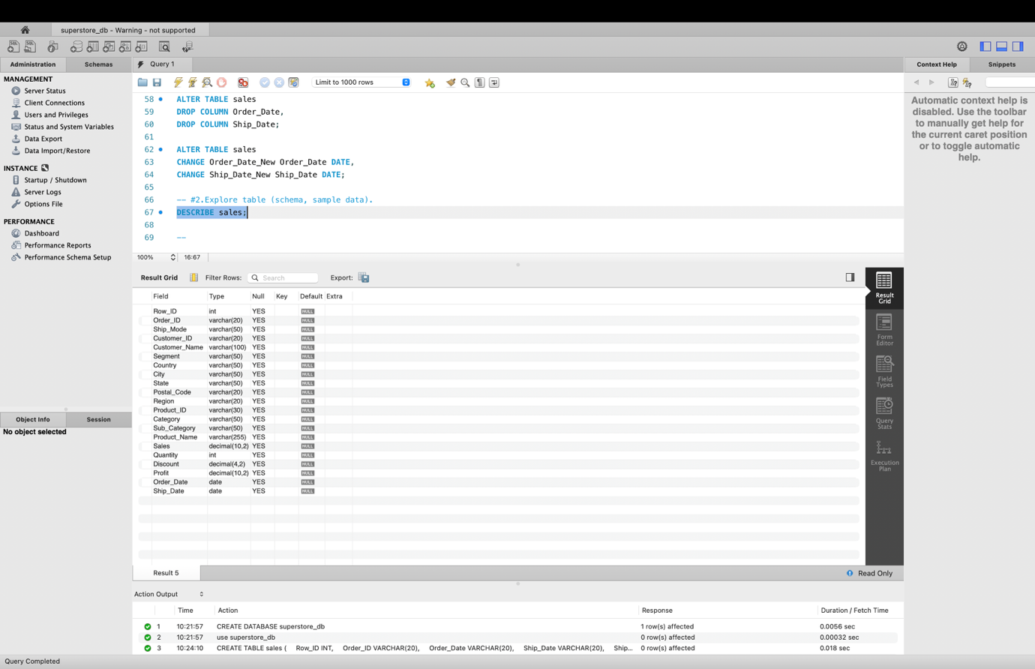
Here I have displayed the schema of the table using DESCRIBE.

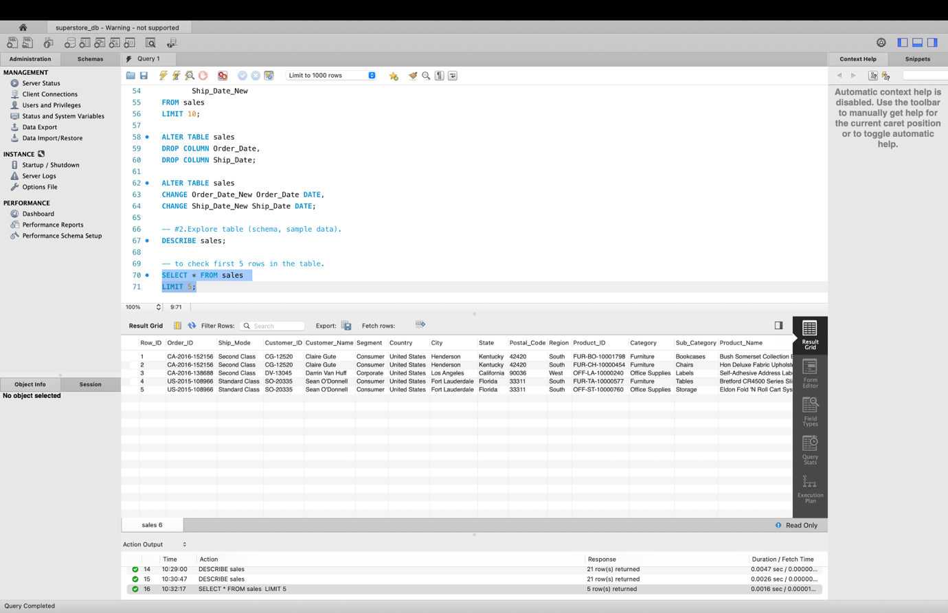Here I have printed the first 5 rows in the table with using limit.

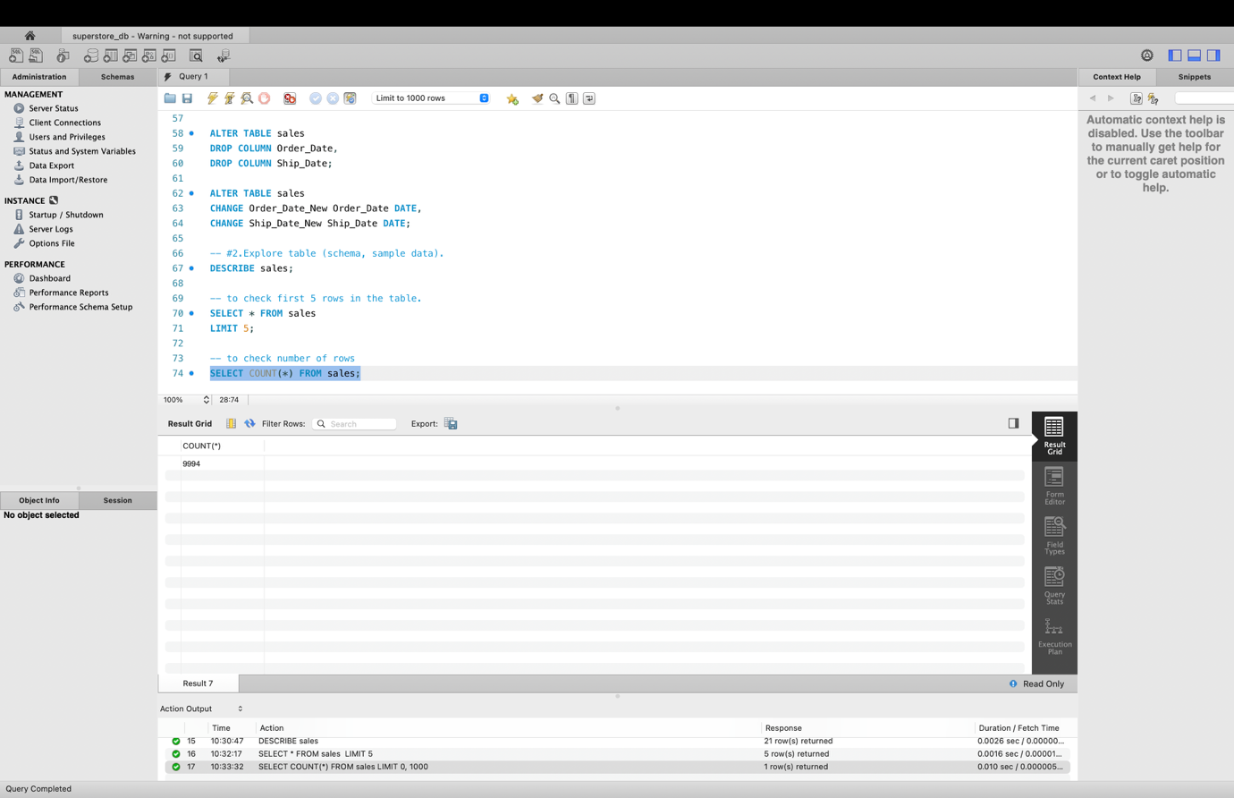Here I have displayed the row count.

3.Apply WHERE filters (region, category, date, sales).

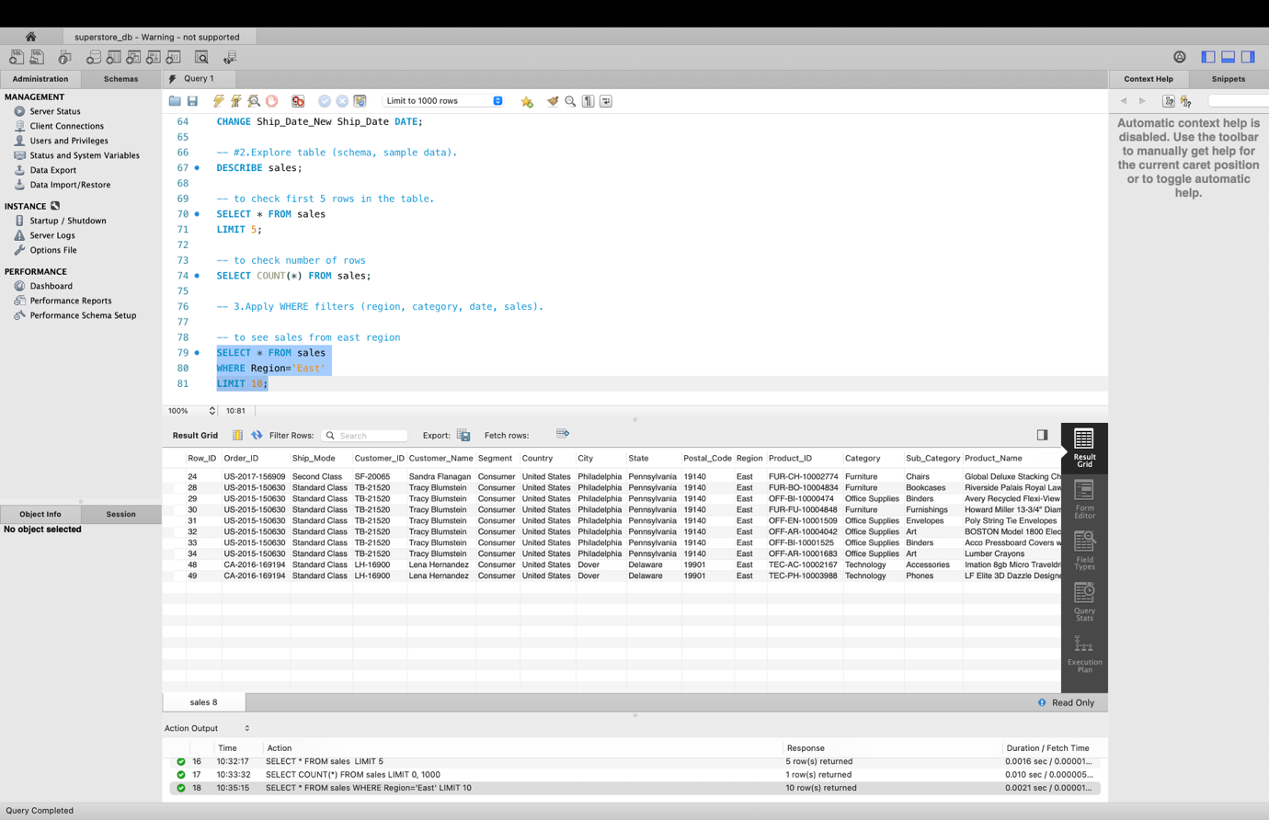Here I have filtered top 10 rows that has the Region as East in the table.

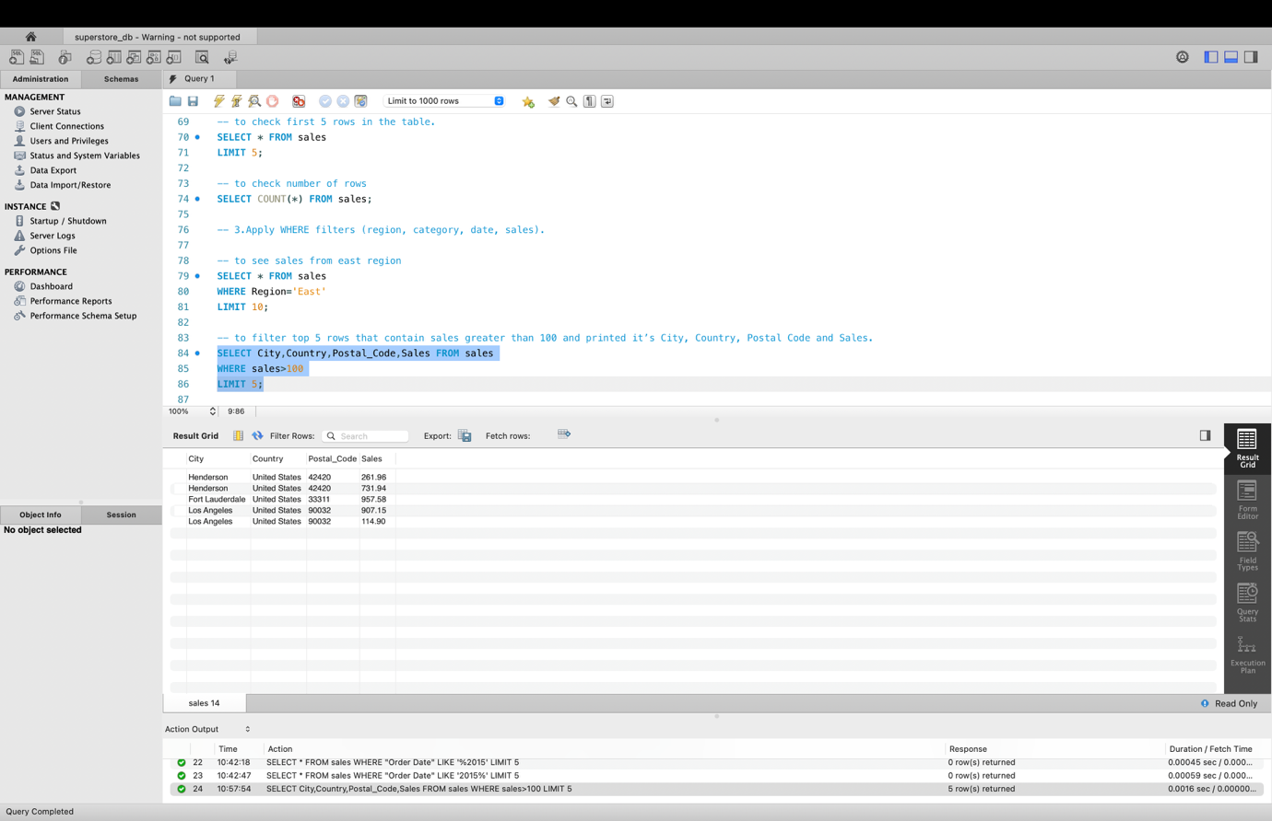Here I have filtered top 5 rows that contain sales greater than 100 and printed it’s City, Country, Postal Code and Sales.

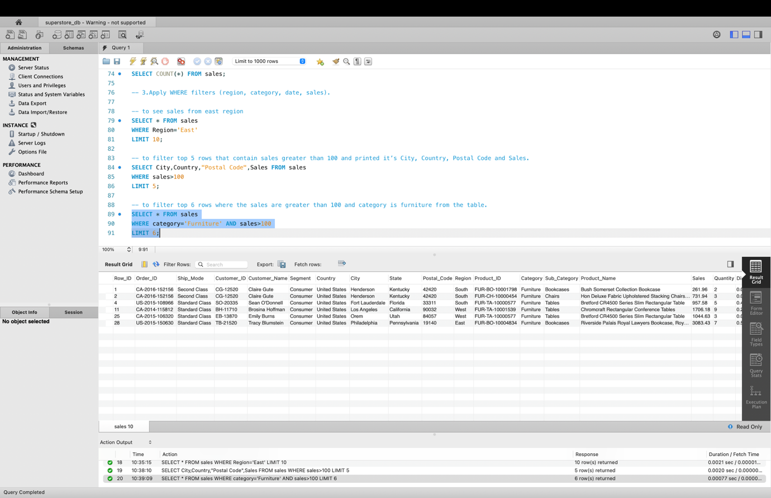
Next I have printed top 6 rows where the sales are greater than 100 and category is furniture from the table.

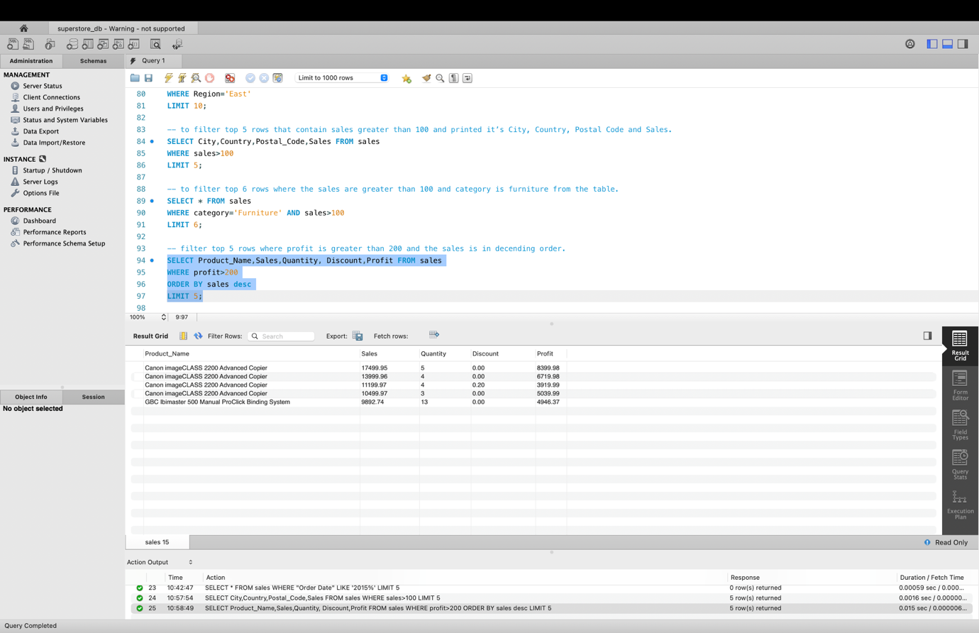In the above screenshot I have filtered top 5 rows where profit is greater than 200 and the sales is in descending order.

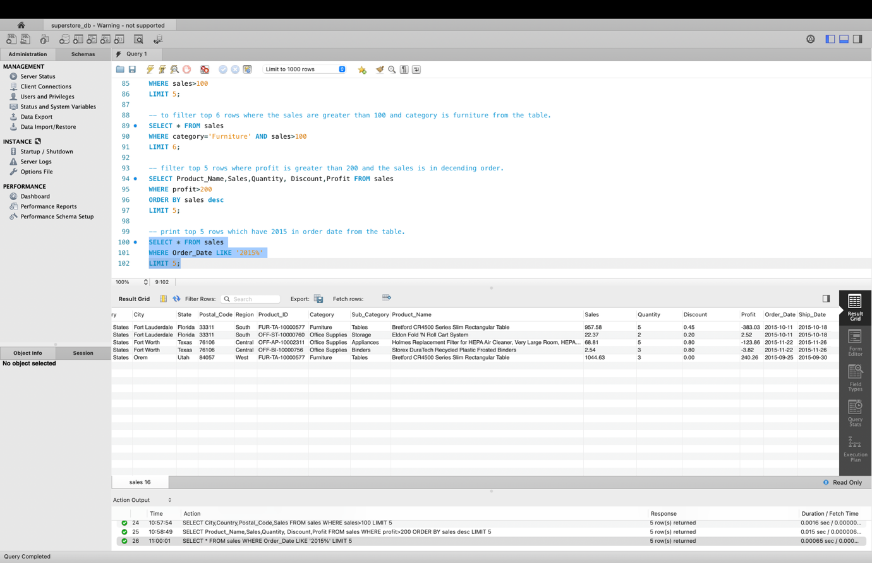Also I printed top 5 rows which have 2015 in order date from the table.

4.Use GROUP BY for aggregations (sales, quantity, averages).

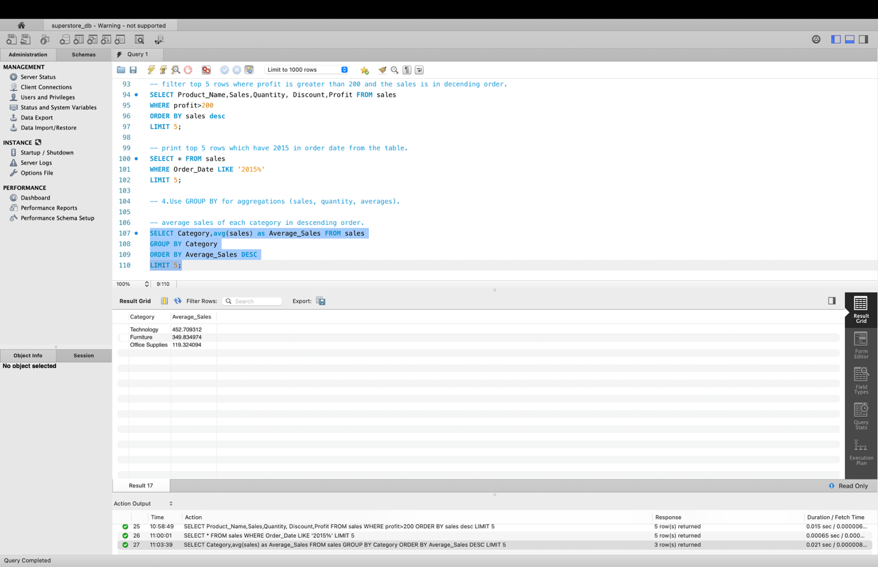Here I have printed the average sales of each category in descending order from the table and used Average sales as the label for column.

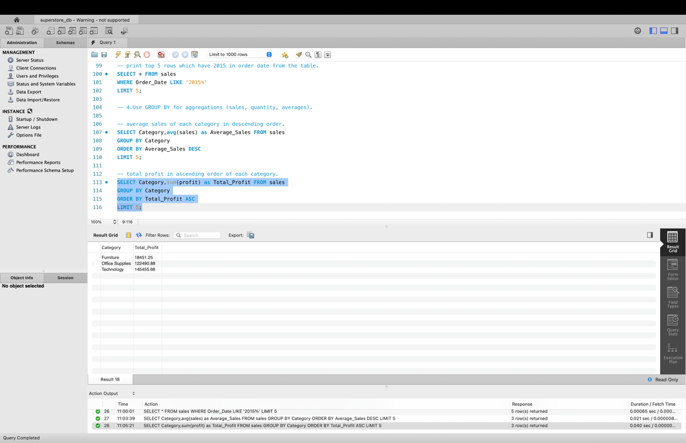
Next I have printed total profit in ascending order of each category.

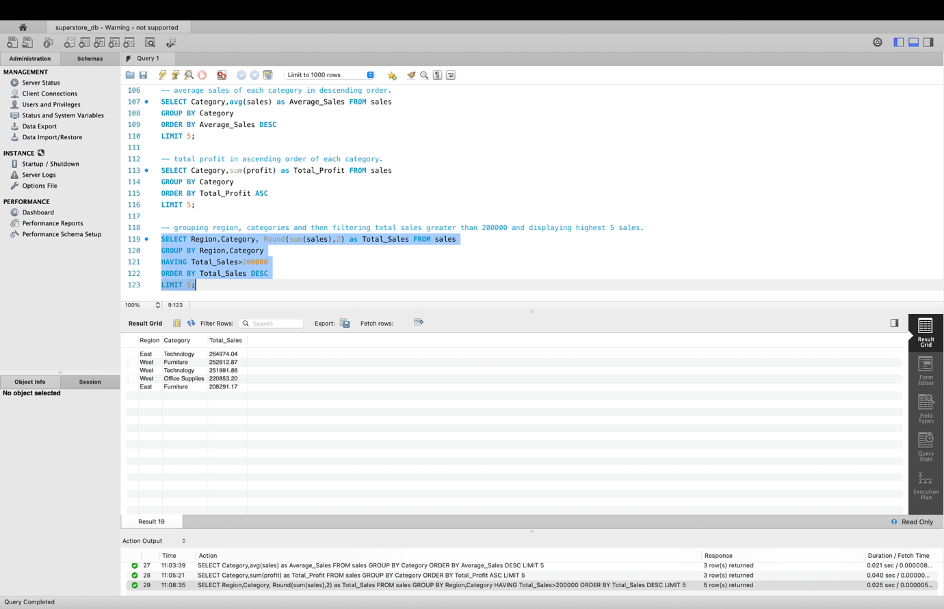Here I have grouped region and categories and the total sales greater than 200000 and the highest 5 sales are displayed.

5.Sort and limit results (top products, top categories).

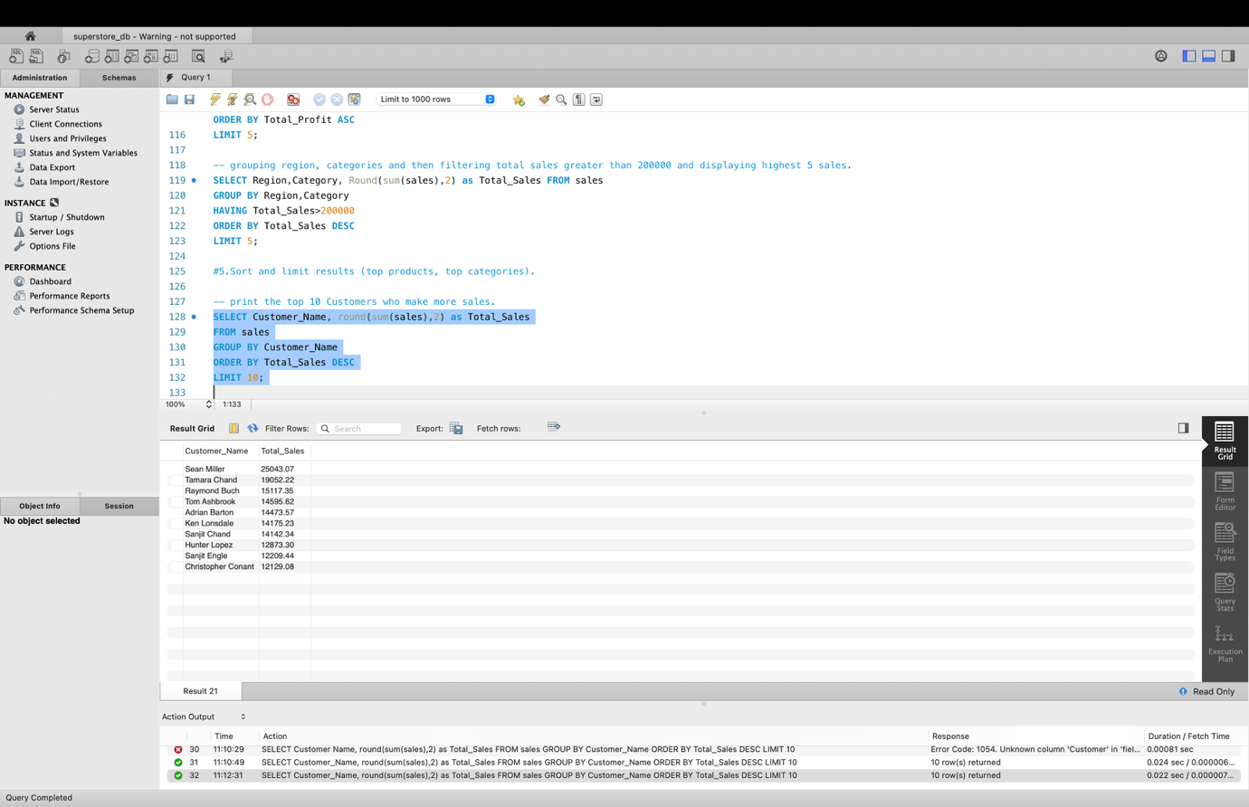Next I have printed the top 10 Customers who make more sales.

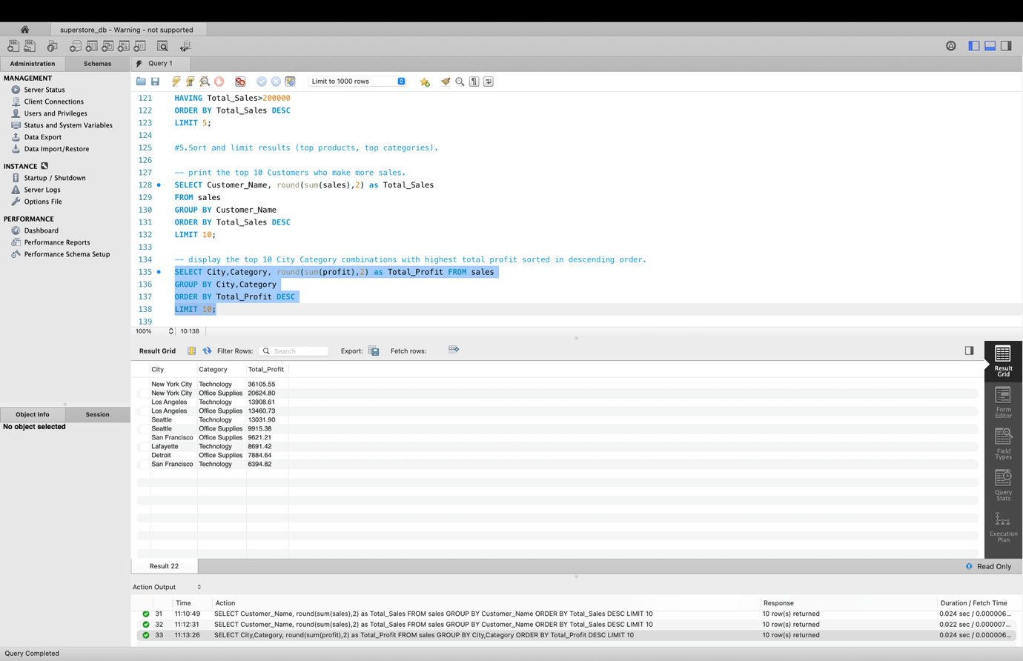Here it displays the top 10 City Category combinations with highest total profit sorted in descending order.

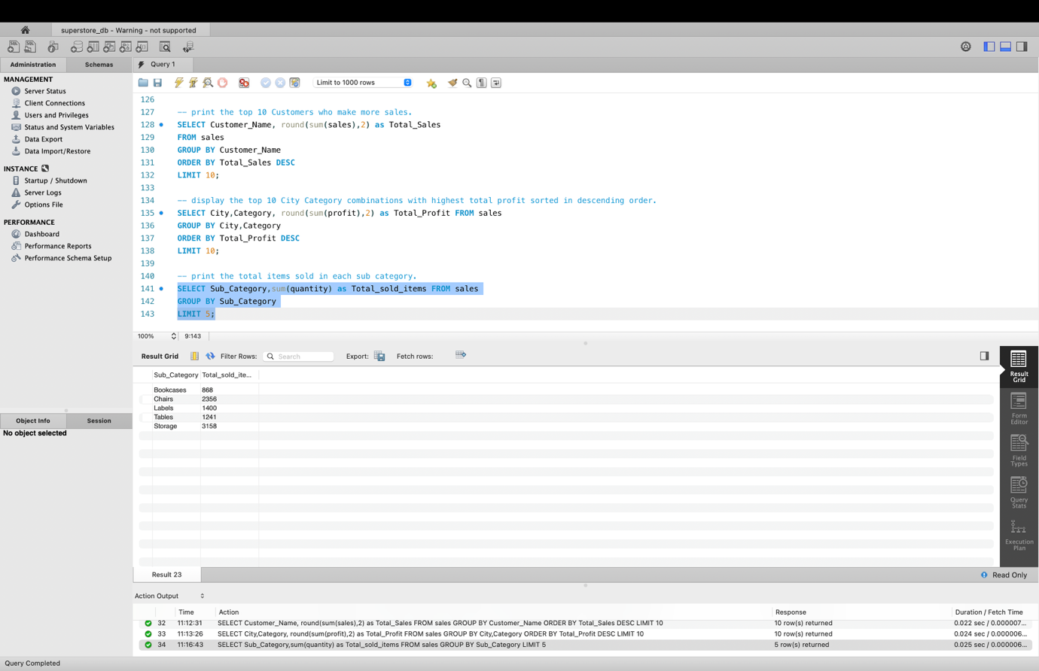Next I have printed the total items sold in each sub category.

6.Solve use cases (monthly trends, top customers, duplicates).

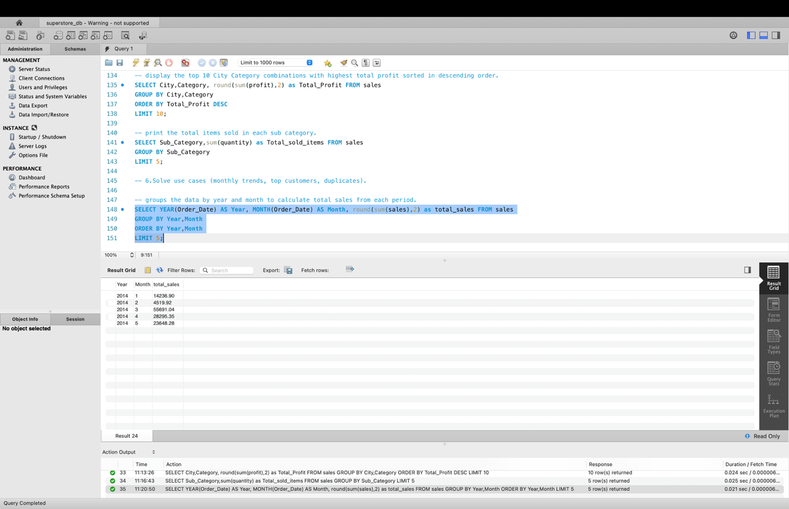
This query extracts the year and month from the Order Date, then groups the data by year and month to calculate total sales from each period.

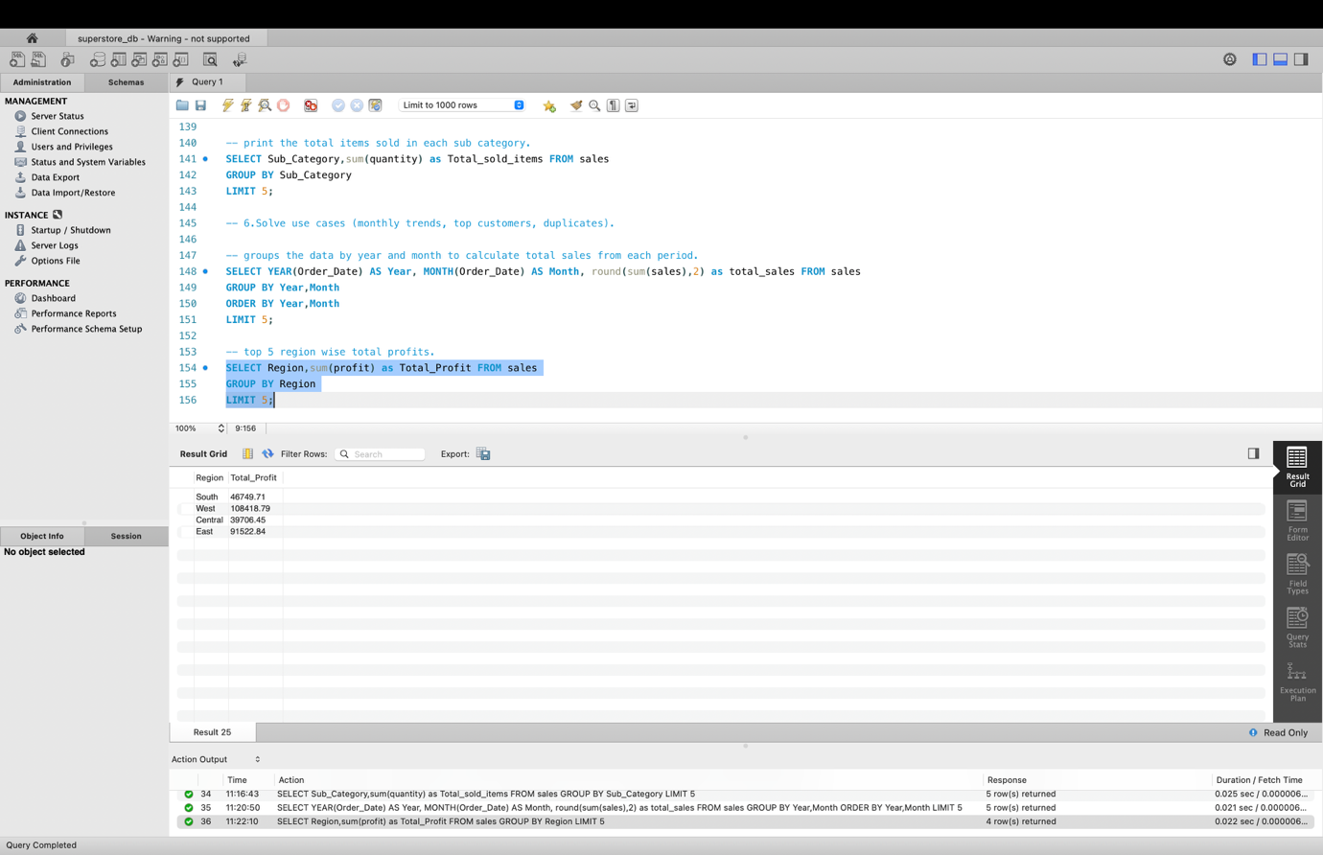Next query results top 5 region wise total profits.

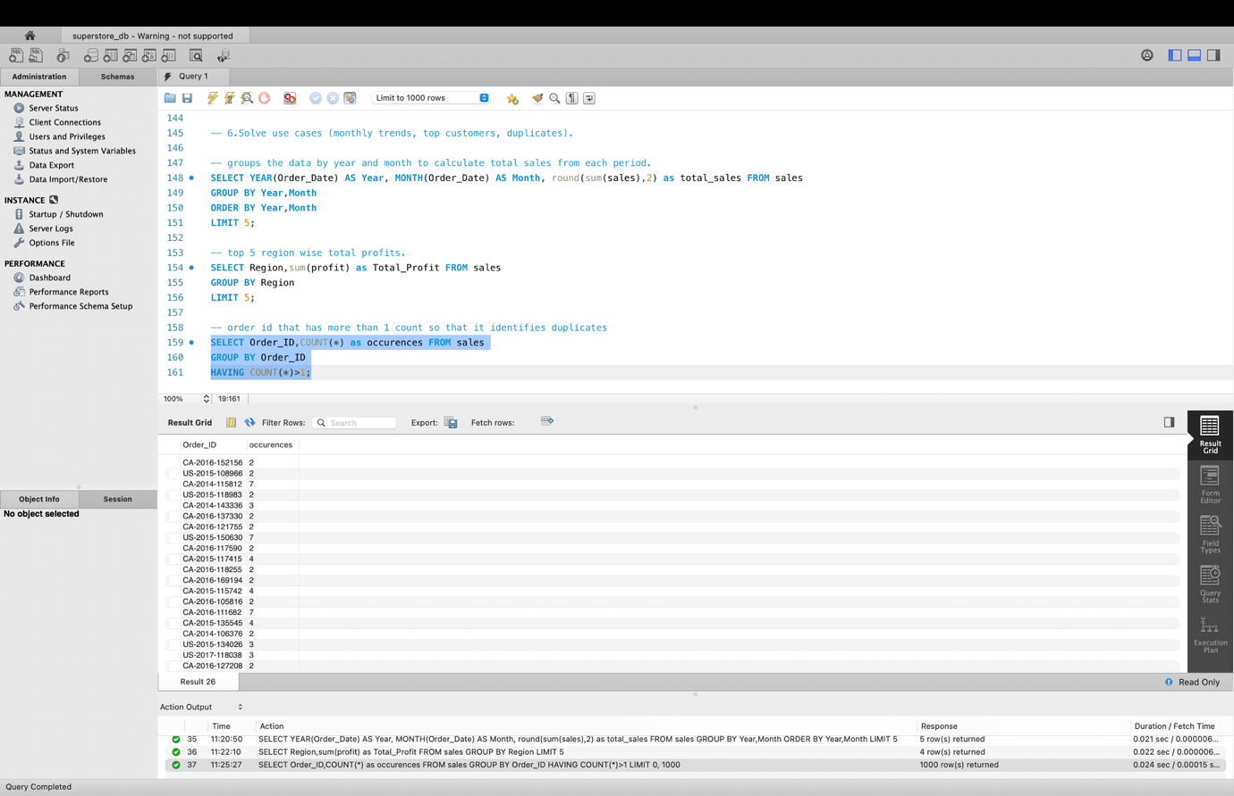This query returns order id that has more than 1 count that is it identifies duplicates.

7.Validate results (row counts, data quality).

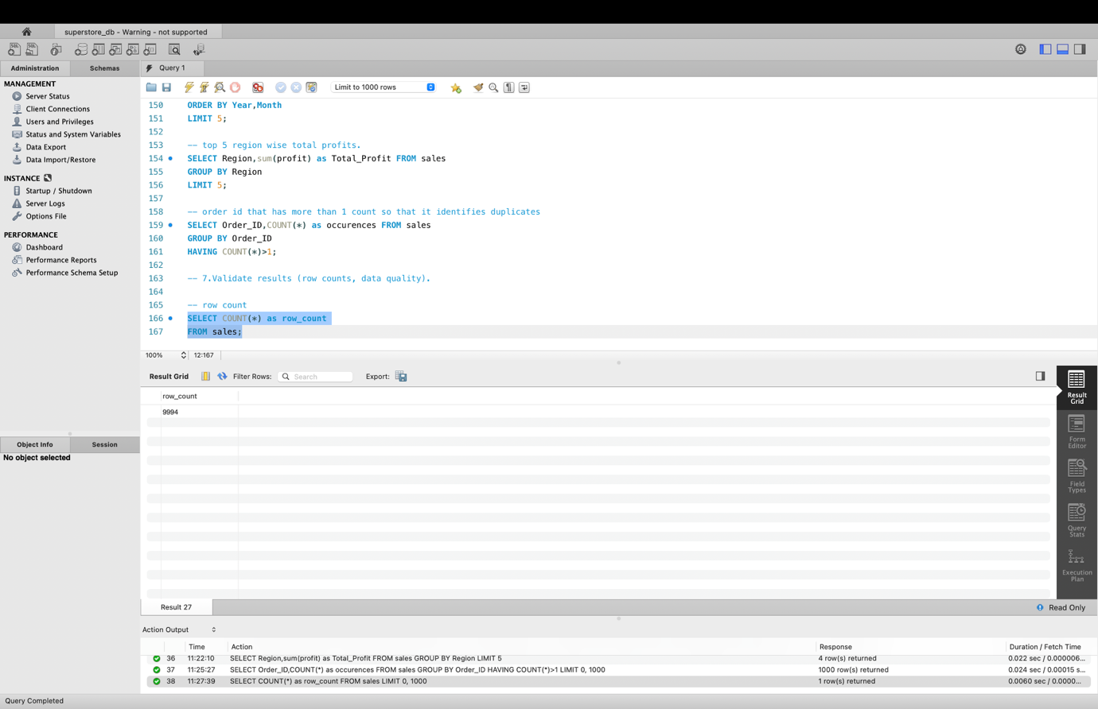
Next query shows how many rows are present in the table.

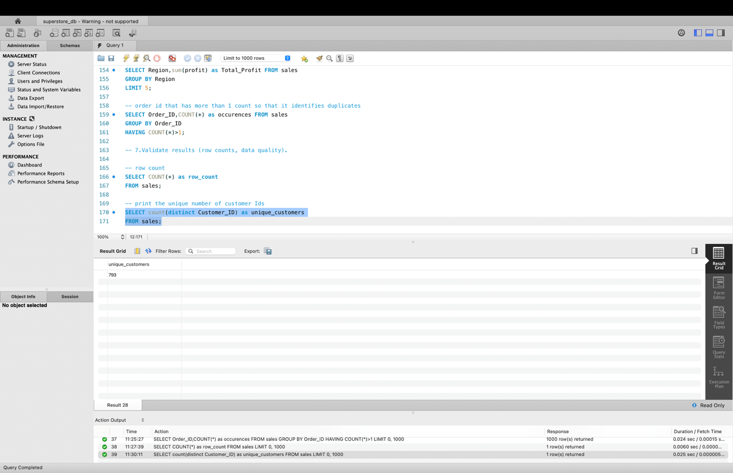Next I have print the unique number of customer Ids (for duplicates).

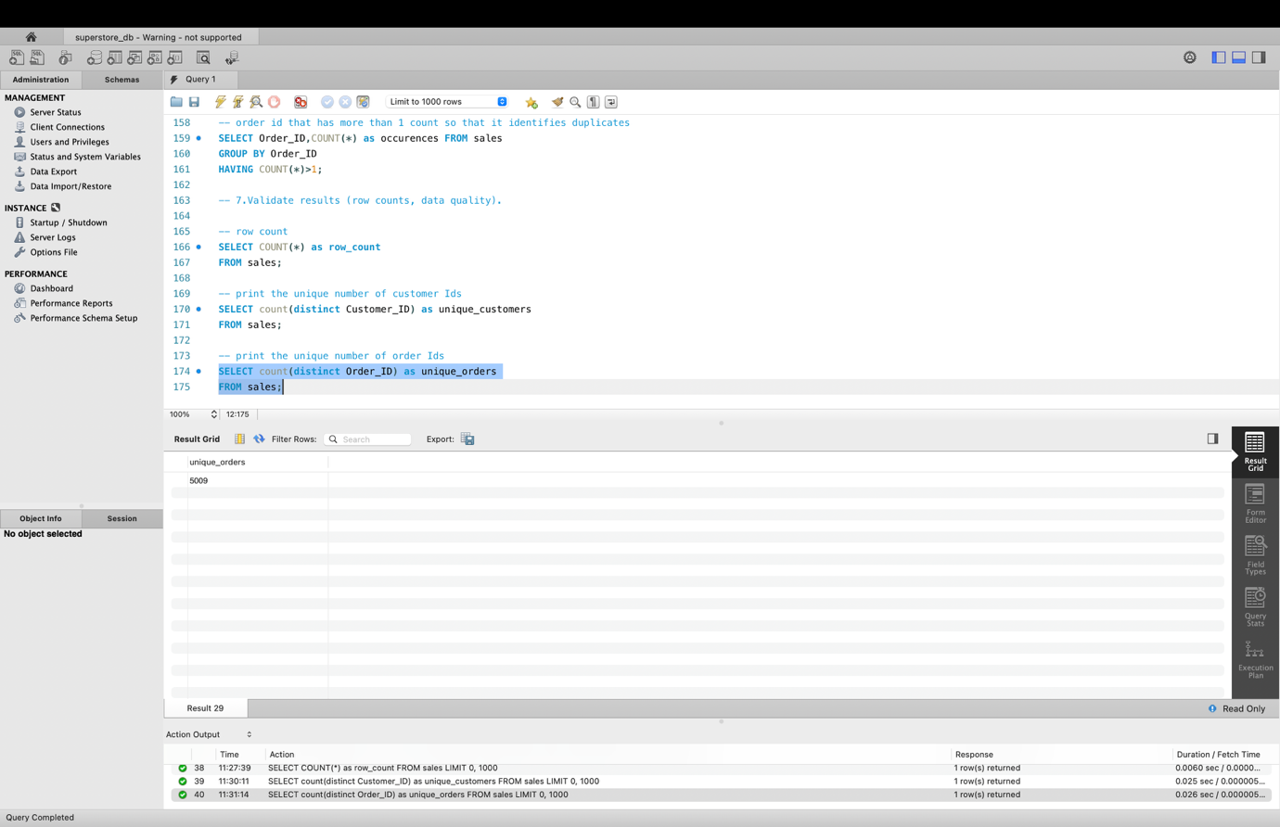Next I have print the unique number of order ids (for duplicates).

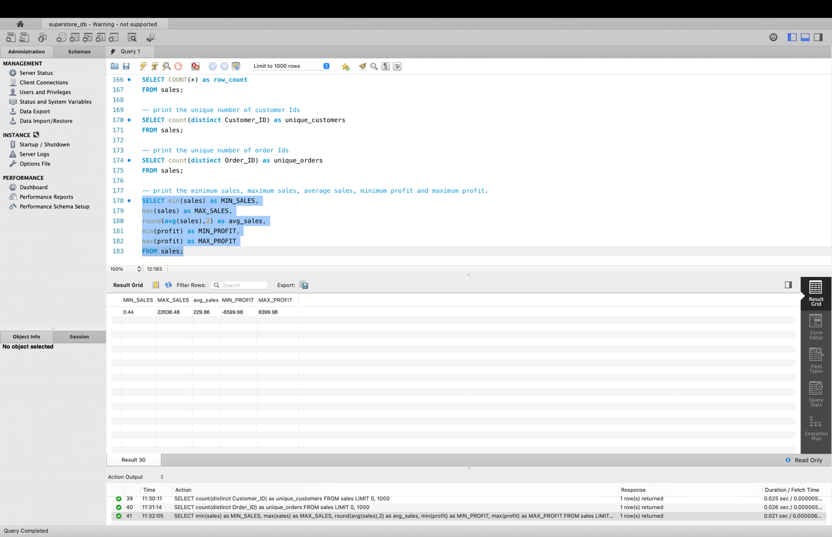Next I have printed the minimum sales, maximum sales, average sales, minimum profit and maximum profit.

